**Kết quả chạy giải trình tự 50 gen trong điều trị đích ung thư**

|  |  |  |
| --- | --- | --- |
| **Gene** | **Result** | **Frequence** |
| ABL1 | Detected | - |
| AKT1 | No mutation detected | - |
| ALK | No mutation detected | - |
| APC | c.G4425A:p.T1475T,  c.G4479A:p.T1493T,  c.4607delA:p.T1538Lfs*9,  c.4661delA:p.T1556Lfs*9 | - |
| ATM | c.2572dupT:p.N859* | - |
| BRAF | No mutation detected | - |
| CDH1 | No mutation detected | - |
| CDKN2A | No mutation detected | - |
| CSF1R | No mutation detected | - |
| CTNNB1 | No mutation detected | - |
| EGFR | c.G973A:p.V325I,  c.G1639A:p.V547I,  c.G1774A:p.V592I,  c.G1615A:p.V539I | - |
| ERBB2 | No mutation detected | - |
| ERBB4 | Detected | - |
| EZH2 | No mutation detected | - |
| FBXW7 | No mutation detected | - |
| FGFR1 | No mutation detected | - |
| FGFR2 | No mutation detected | - |
| FGFR3 | c.C1206A:p.P402P,  c.C1212A:p.P404P,  c.G1617A:p.T539T,  c.G1953A:p.T651T,  c.G1959A:p.T653T | - |
| FLT3 | Detected | - |
| GNA11 | No mutation detected | - |
| GNAQ | No mutation detected | - |
| GNAS | No mutation detected | - |
| HNF1A | No mutation detected | - |
| HRAS | No mutation detected | - |
| IDH1 | No mutation detected | - |
| IDH2 | No mutation detected | - |
| JAK2 | No mutation detected | - |
| JAK3 | No mutation detected | - |
| KDR | c.3868delA:p.S1290Afs*38 | - |
| KIT | No mutation detected | - |
| KRAS | No mutation detected | - |
| MET | No mutation detected | - |
| MLH1 | c.T428A:p.V143D,  c.T1151A:p.V384D,  c.T857A:p.V286D,  c.484dupC:p.L163Pfs*13,  c.1207dupC:p.L404Pfs*13,  c.913dupC:p.L306Pfs*13 | - |
| MPL | No mutation detected | - |
| NOTCH1 | No mutation detected | - |
| NPM1 | No mutation detected | - |
| NRAS | No mutation detected | - |
| PDGFRA | c.A1701G:p.P567P,  c.A1740G:p.P580P,  c.A1776G:p.P592P | - |
| PIK3CA | c.244delT:p.F83Lfs*17 | - |
| PTEN | c.963delA:p.N323Mfs*21,  c.372delA:p.N126Mfs*21,  c.1482delA:p.N496Mfs*21 | - |
| PTPN11 | No mutation detected | - |
| RB1 | No mutation detected | - |
| RET | c.G2307T:p.L769L | - |
| SMAD4 | No mutation detected | - |
| SMARCB1 | No mutation detected | - |
| SMO | c.989delT:p.W331Gfs*56 | - |
| SRC | No mutation detected | - |
| STK11 | c.165dupG:p.E57Gfs*106 | - |
| TP53 | c.G418A:p.V140M,  c.G337A:p.V113M,  c.G697A:p.V233M,  c.G814A:p.V272M | - |
| VHL | No mutation detected | - |

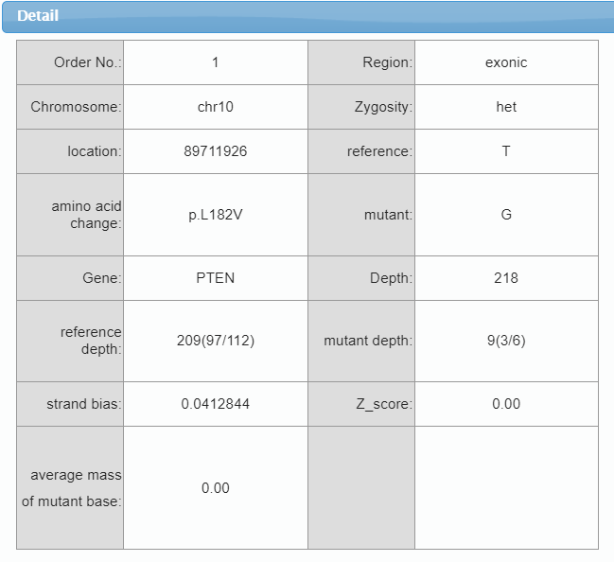

**Medication Guidance:**

**1. Being approved by FDA/CFDA to be used for guidance of individualized Other tumors medication**

Not found

**2. Being approved by FDA/CFDA to be used for guidance of individualized medication of other cancers**

|  |  |  |  |  |  |
| --- | --- | --- | --- | --- | --- |
| Gene | Mutation | Drug | Approved indications | Drug reaction | Evidence |
| PTEN | p.L182V | Cetuximab,Panitumumab | Colorectal Cancer | Negative Correlation | Clinical Trial[1] |

**3. Clinical research drugs**

|  |  |  |  |  |  |
| --- | --- | --- | --- | --- | --- |
| Gene | Mutation | Drug | Study cancer type | Drug reaction | Evidence |
| PTEN | p.L182V | Alpelisib (BYL719) | Breast Cancer | Negative Correlation | Clinical Trial[2] |
| PTEN | p.L182V | Olaparib | Endometrial Cancer | Positive Correlation | Case Report[3] |
| PTEN | p.L182V | Temsirolimus | Endometrial Cancer | Negative Correlation | Clinical Trial[4] |
| PTEN | p.L182V | MK-2206 | Pancreatic Cancer | Positive Correlation | Case Report[5] |
| PTEN | p.L182V | Everolimus | PCa(prostatic cancer) | Positive Correlation | Clinical Trial[6] |
| PTEN | p.L182V | GSK2636771 | PCa(prostatic cancer) | Positive Correlation | Case Report[7] |
| PTEN | p.L182V | Sirolimus | Tumor | Positive Correlation | Clinical Trial[8] |

**Reference：**

1. De Roock W, De Vriendt V, et al. KRAS, BRAF,PIK3CA, and PTEN mutations: implications for targeted therapies in metastaticcolorectal cancer. Lancet Oncol. 2011 Jun;12(6):594-603.  
2. Juric D, Castel P,, et al. Convergent loss of PTENleads to clinical resistance to a PI(3)Kα inhibitor. Nature. 2015 Feb12;518(7538):240-4.  
3. Forster MD, Dedes KJ, et al. Treatment with olaparib in a patient with PTEN-deficient endometrioid endometrial cancer. Nat Rev Clin Oncol. 2011May;8(5):302-6.  
4. Oza AM, Elit L, et al. Phase II study of temsirolimus in women with recurrent ormetastatic endometrial cancer: a trial of the NCIC Clinical Trials Group. J Clin Oncol. 2011 Aug 20;29(24):3278-85.  
5. Yap TA, Yan L, et al. First-in-man clinical trial of the oralpan-AKT inhibitor MK-2206 in patients with advanced solid tumors. J Clin Oncol.2011 Dec 10;29(35):4688-95.  
6. Templeton AJ, Dutoit V, et al. Phase 2 trial ofsingle-agent everolimus in chemotherapy-naive patients with castration-resistant prostate cancer (SAKK 08/08). Eur Urol. 2013 Jul;64(1):150-8.  
7. Arkenau HT, Mateo J, et al. A phase I/II, first-in-human dose-escalation study of GSK2636771 in patients (pts) with PTEN-deficient advanced tumors. Journal of Clinical Oncology 2014;32.  
8. Komiya T, Blumenthal GM, et al. A pilot study of sirolimus (S) in subjects with Cowden syndrome (CS) with germ-line mutations in PTEN. Journal of Clinical Oncology 2013;31.  
9. Chalhoub N, Baker SJ. PTEN and the PI3-kinase pathway in cancer. Annu Rev Pathol. 2009;4:127-50.